**Exam 1 Report**

**Xin Li**

**AEEM 7010**

**1. Membership Functions:**



*Membership Function of “Water Flow Rate”*



*Membership Function of “Dam Water Level”*

Both membership functions of “Water Flow Rate” and “Dam Water Level” are simply distributed evenly over their domains with relatively same overlaps over each other.

As fuzzy set of “Water Flow Rate” is:

[very weak, weak, average, strong, very strong]

And the fuzzy set of “Dam Water Level” is:

[very low, low, medium, high, very high]

The transitions among these fuzzy set members are correlated in a chain and there is no sudden transition happens from one state into another state. For example, from “very weak” to “very strong” of “Water Flow Rate, the flow rate must go through the inter-states, such as “weak”, “average”, and “strong”.

Thus, evenly distributed membership functions among input domains should reach a better result for the output.



zero

Membership Function of “Power Output”

The fuzzy set of “Power Output” is:

[zero, low, mid, high]

Different from the membership functions of input, the membership function setup for output “Power Output” should not be evenly distributed. As we see from the example plot, the output has 4 levels of power outputs. We set a membership function over [0, 50] for the “low” output, a membership function over [0, 100] for the “mid” output, and a membership function over [50, 170] for the “high” output. Finally, we need to set a very sharp membership function over [-1, 1] for the “zero” output.

Note that MF of “mid” has center of gravity at 50 which is matching the example plot’s mid output. Same setup for the MF of “low” and “high”, their centers of gravity are matching the example plot’s low and high output (approximate 15 for “low” and 110 for “high”).

**2. Rule Based Matrix:**



*Input Heatmap*

|  |  |  |  |  |  |  |
| --- | --- | --- | --- | --- | --- | --- |
| **AND** | | Dam Water Level (Y) | | | | |
| very low | low | medium | high | very high |
| Water Flow Rate (X) | very weak | low | low | low | low | mid |
| weak | low | low | low | low | mid |
| average | low | low | low | mid | high |
| strong | mid | mid | mid | high | high |
| very strong | mid | mid | mid | high | 0 |

*Rule Base Matrix*

Base on the observation of given control surface plot, we can conduct a heatmap for the inputs to identify the regions for different levels of power output. Note that as the instruction indicated, the power output is 0 when Water Flow Rate is “very strong” and Dam Water level is “very high”.

As our Rule Base Matrix has 25 cells, it indicates that we will have 25 rules to evaluate. For example, the 1th cell of the matrix is interpreted as “IF Water Flow Rate is very weak AND Dam Water Level is very low, THEN the power output is low”. Another example of the 25th cell of the matrix is interpreted as “IF Water Flow Rate is very strong AND Dam Water Level is very high, THEN the power output is 0”.

**3. Control Surface Plot & Comparison:**

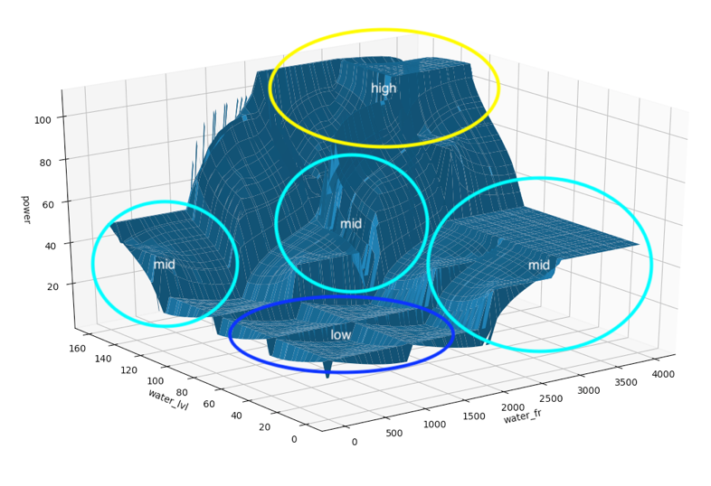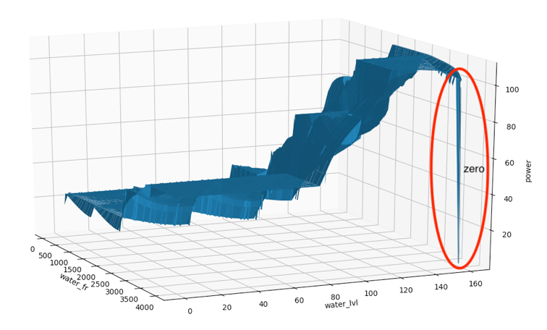

From the observation, it is shown that power output for “low” hit the approximated target value of 18. Also, the power output for “mid” hit the approximated target value of 50 as well as the power output for “high” hit the approximated target value of 110. Note that for very strong Water Flow Rate and very high Dam Water Level, the power output is 0 and it is hidden in the back of plot.

Basically, my plot fits all the significant features of the given control surface plot. However, I found that the more data points I used, the more unsmooth plot I will get. As I debug by using Matlab toolbox with exact same MF and Rule setup, I confirmed that my own toolbox is working well by having very small error. Thus, I assume the reason of having such unsmooth plot is due to the way of how I generate my input data. I learned that for some particular region, such as the “very strong Water Flow Rate – very high Dam Water Level” situation, I need to collect more input data to ensure the 0 power output.

**4. What I Learn:**

A very important lesson that I learned from this exam is that before getting into the problem, it is good to analyze the problem as detail as possible.

For example, this exam problem has two inputs and one output, and I need to analyze their features and correlations first in order to get good result. At my first few attempts of input membership function designs, I used some fancy combinations, such as gradually-increase-overlap and gradually-decrease-overlap for the membership functions. However, I didn’t get very good results. Then I start to analyze the input variables and realize that Water Flow Rate and Dam Water Level are actually linearly distributed within their own domain. That means I should design my membership functions for each of them as even as possible, so that the transitions among the states in each domain are linear. As a result, the MF plots for Water Flow Rate and Dam Water Level are very simple and all “triangle” MFs are evenly overlap each other to cover their entire domain.

Another example is, as we are told there are 5 membership functions for each input variable, we are not told about how many membership functions to use for the output variable. I was struggling at the beginning. Then I start to analyze the output features from the given control surface plot and I found there are three significant power output levels, which are approximately 18, 50, 110. After adding the information of “0 power output for very strong Water Flow Rate and very high Dam Water Level” from the text, I realize the membership functions for the output variable should be 4.

**5. Challenges:**

From the execution point of view, it is not hard for my program to scale to multiple input and multiple output system, since I designed my program to handle such issue at the very beginning. However, the “curse of dimension” is truly a challenge that I need to handle.

For example, for 1 input, the complexity is just $O(n)$. In this exam, I have 2 inputs and the complexity suddenly becomes ${O(n}^{2})$. Each testing takes me a long time to wait for the result which makes the tuning process very inefficient. Now, if I am given a problem that has 16 inputs and 3 outputs, that means the complexity will be ${O(n}^{16})$ and it is impossible for computer to run. The solution for such issue can be handled by using PCA or SVD. After applying the eigen decomposition to the dataset, PCA or SVD can help me to identify the most useful variables by ranking their eigen values (which reflects the corresponding variance of the dimension). At this point, if I decide to pick 3 the most useful dimensions, I can reduce the dimension from 16 to 3, which reduce my computation complexity from ${O(n}^{16})$ to ${O(n}^{3})$, which is much reasonable for computing. However, such PCA or SVM techniques require the collected dataset in hand for analysis. How to collect data will be another potential challenge in this case, since it can be very costly to collect good data.

**6. Code Details:**

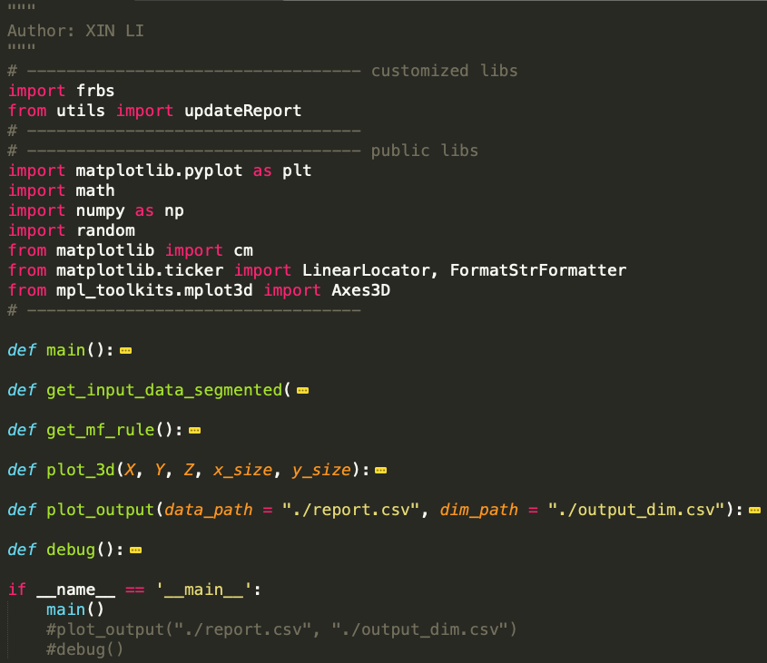

[exam.py]

* exam.py is the main program to run.
* “main()” is the main function to feed input data and return the output data.
* “plot_output()” can rerun previous saved output result, so we don’t need to rerun the previous long execution. To rerun the result, place the “output_dim.csv” and “report.csv” in “./output_backup/ouput_xxx/” to the current directory. I have 2 version of outputs, which are ouput_2500 and ouput_62500.
* “debug()” is used to check individual input data and its output for debugging purpose.

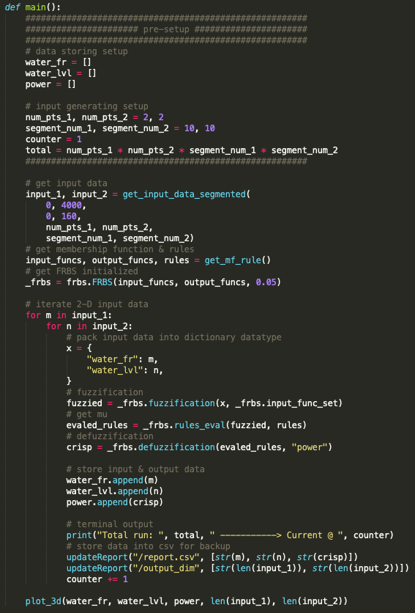

[exam.py – main()]

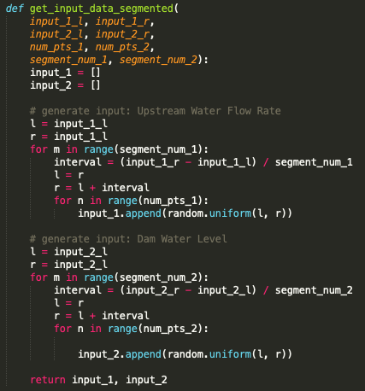

[exam.py – get_input_data_segmented()]



[exam.py – get_mf_rule()]

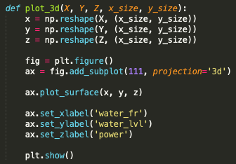

[exam.py – plot_3d()]

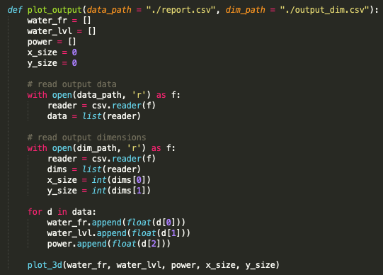

[exam.py – plot_output()]

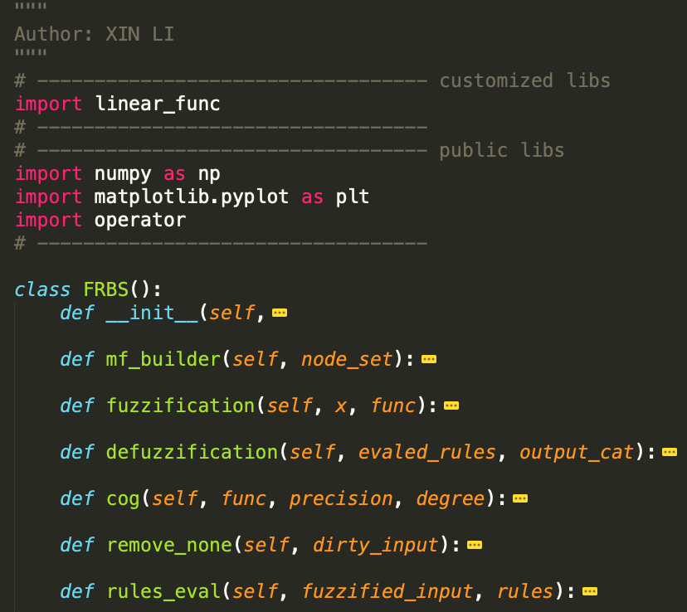

[frbs.py]

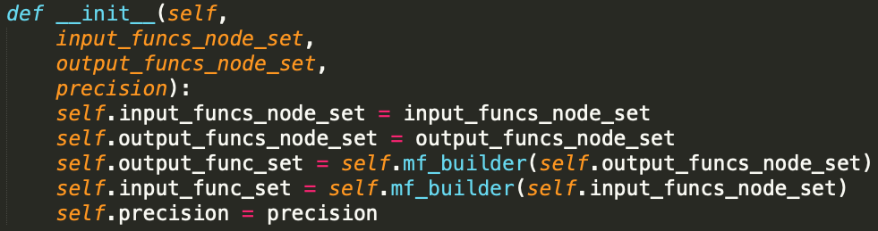

[frbs.py – init()]

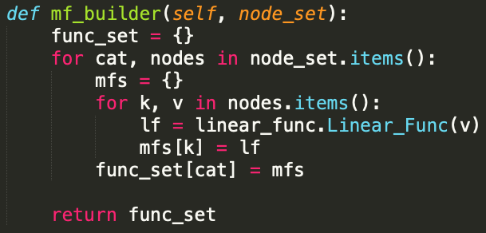

[frbs.py – mf_builder()]

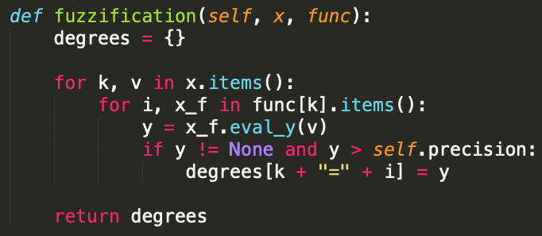

[frbs.py – fuzzification()]

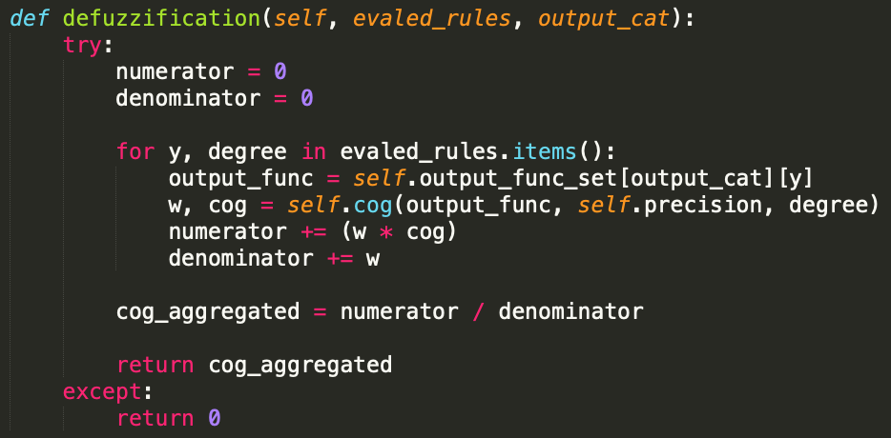

[frbs.py – defuzzification()]

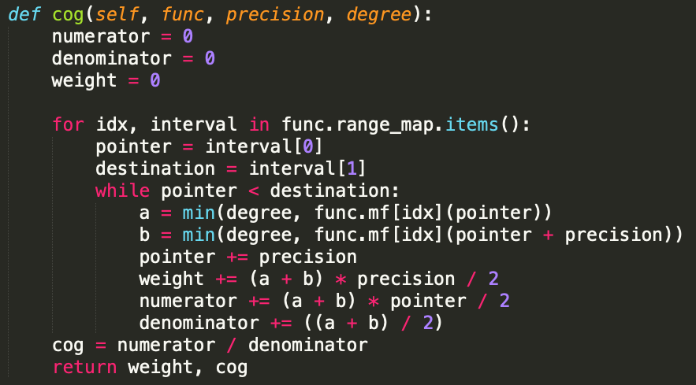

[frbs.py – cog()]

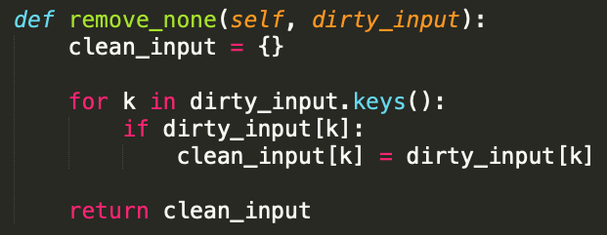

[frbs.py – remove_none()]

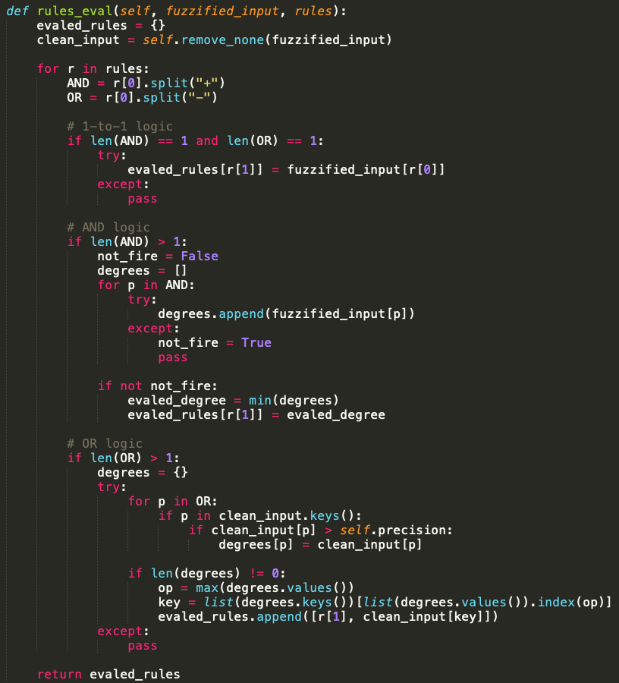

[frbs.py – rules_eval()]

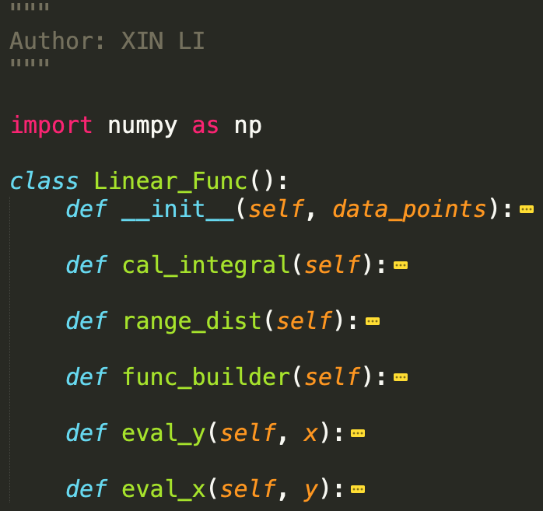

[linear_func.py]

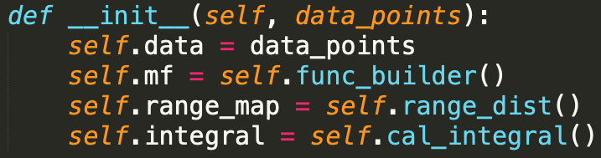

[linear_func.py – init()]

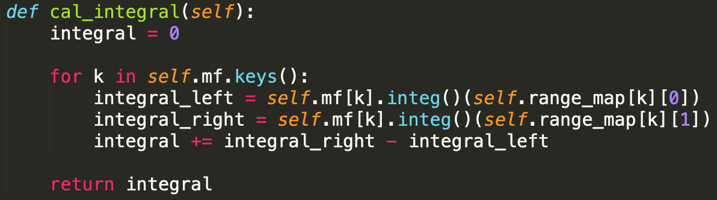

[linear_func.py – cal_integral()]

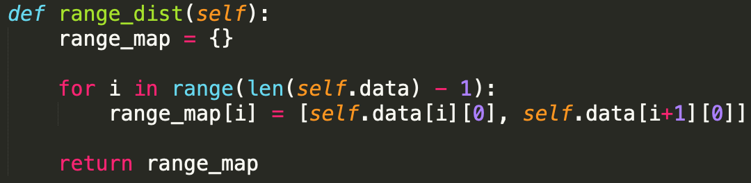

[linear_func.py – range_dist()]

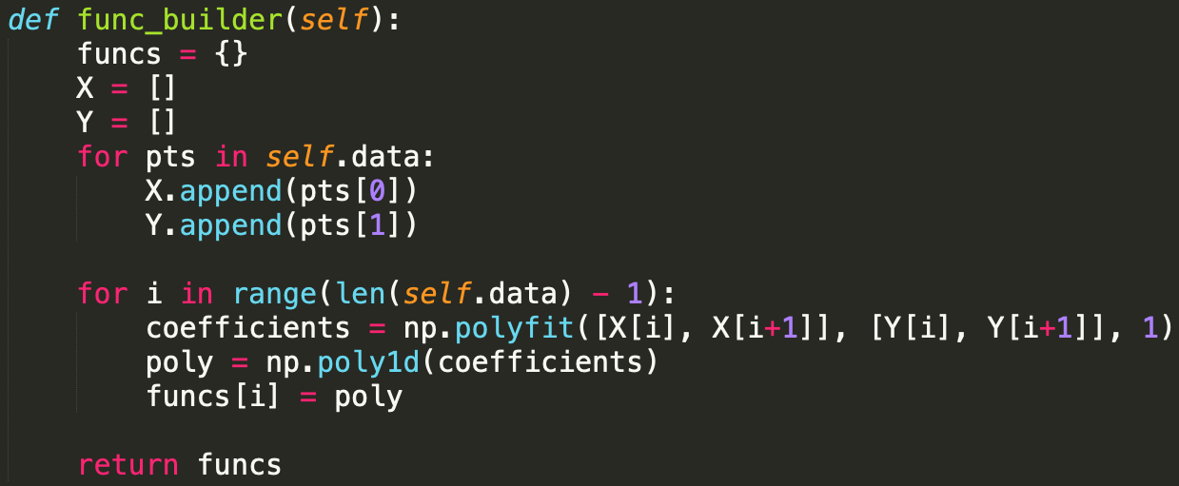

[linear_func.py – func_builder()]

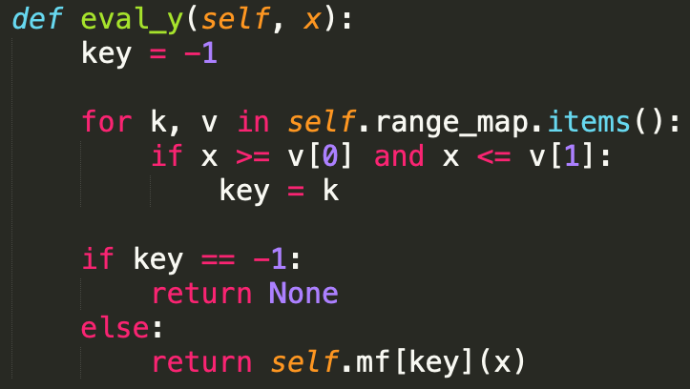

[linear_func.py – eval_y()]

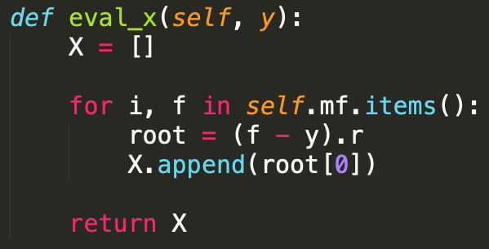

[linear_func.py – eval_x()]

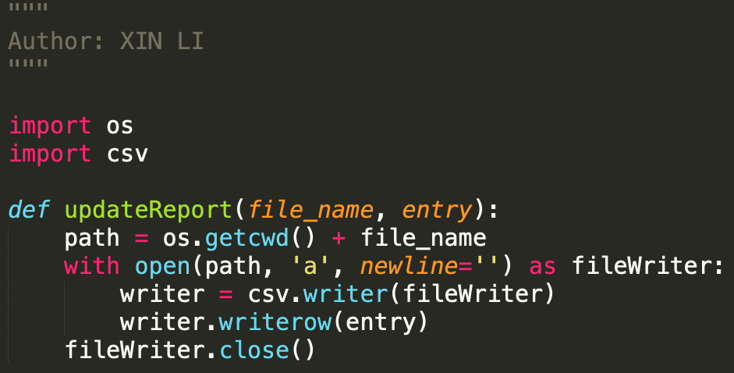

[utils.py – updateReport()]